Introduction & Welcome
(If you notice any errors on this guide or have any feedback please contact us)
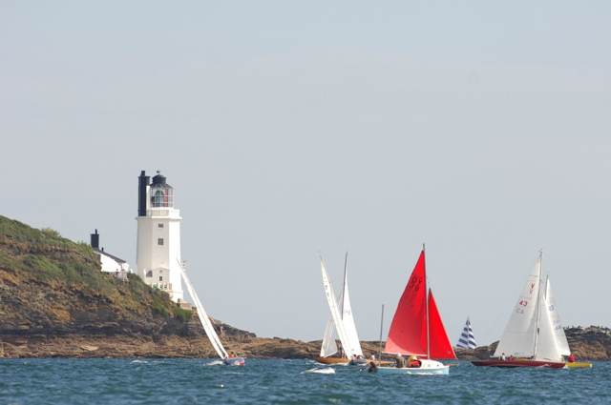
Mylor Sailing School is located in Mylor Yacht Harbour which is in the beautiful Fal Estuary on the south coast of Cornwall, near Falmouth. This is the third natural deepest estuary in the world. Mylor Sailing School provides accessible sailing and powerboating activities for all levels of disabilities including sailing and powerboating. There are Royal Yachting Association Achievement Awards for sailing and powerboating for people with physical disabilities and also a scheme for people the learning difficulties.

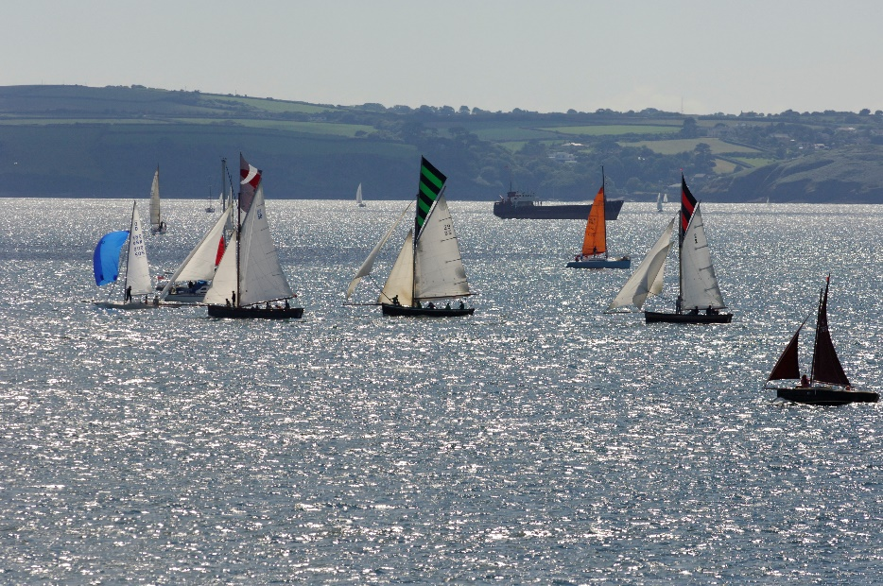
The entire estuary area which is better known as the Carrick Roads is protected as an Area of Outstanding Natural Beauty, from the mouth which has St Anthony Lighthouse (aka Fraggle Rock) to one side and Pendennis Castle to the other, deep into the tree lined creeks to Truro. It is home to many wading birds, seals and otters, not to mention all the basking sharks and dolphins that come into the Roads to feed.
Contents
Item | Page No
General Information | 3
Boat & Classroom Information including access to and from boats | 3, 4 & 5
Booking and Pre-Arrival information | 5
Visiting Us –  Train, Bus, Taxi, Water-Taxi, Car, Dropping Off | 5 & 6
Arrival & Access, Public toilets and showers | 7 & 8
Extra Equipment Available | 8
Assistance Dogs | 8 & 9
Staff Training | 9
Future Plans | 10
Facilities Available around Mylor Sailing School | 11
Accessible Accommodation | 12
Full Contact Details | 13
Site Map – Mylor Yacht Harbour | 14
General Information
The whole centre is accessible by electric and manual wheelchairs. Accessible facilities for toilets and showers available in the harbour close by and are well sign-posted. There is also baby and young child changing facilities. Classrooms and huts are very easy to find all being in close proximity and staff will guide all participants to where they need to go. Classrooms all well signed with dark blue writing on a white background.

Waterproofs are provided for all activities and there are also either buoyancy aids or life jackets for safety. We have a large range of different sizes. In the unlikely event of you falling in the water, you will be wearing either a manually inflated life jacket where you will have to pull a cord and this will be shown to you on arrival, or an automatically inflated life jacket where you will not need to do anything as it will inflate on the impact of water. We normally give the automatic life jackets to those who cannot swim very well, the less confident or anyone who finds it difficult to follow instructions, e.g. someone with a learning difficulty. Full instructions are given at time of donning the life jackets.

Boat & Classroom Information
Powerboating
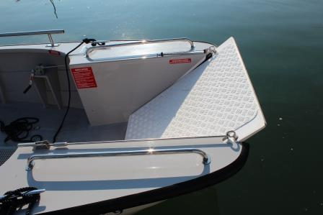
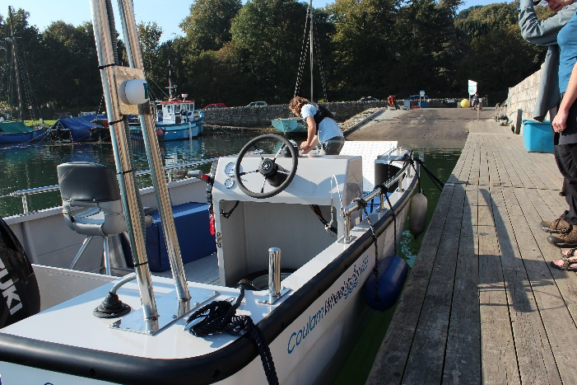
There is a wheelchair friendly powerboat where the front section flaps down to allow ease of boarding for those with any kind of mobility problems. It is a high sided boat but has great access

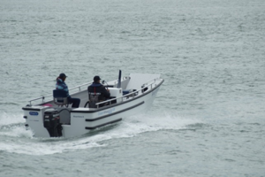
This fantastic bit of equipment has been especially designed to give a thrilling ride and has comfortable foam seats. Other seats are also available so please do not hesitate to ask.This boat is designed and manufactured by The Wheelyboat Trust and you can read more about this organisation by clicking HERE
We bring the boat into a slipway ramp close to the school and the front section is controlled by a winch which we can then lower down completely to enable boarding for people with restricted mobility or wheelchair users.
You can have a go at driving the boat and this is also wheelchair users too as the seat comes away from the steering area so you can manoeuvre a wheelchair in quite easily.
There is a Royal Yachting Association scheme of achieivement and it may be possible to gain the Powerboat 2 License.
You can read HERE for more details on the Powerboat Level 2 course on our website.
There is also a RYA Powerability acheivement scheme for people with learning difficulties.
Sessions may include a trip up the river to see the wildlife or out to Black Rock to see some seals. Possibly a stop on a beach somewhere. This is all wind and weather dependent. Your instructor will let you know the plan for the session.
Sailing
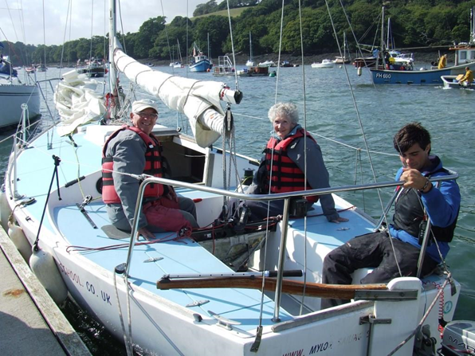
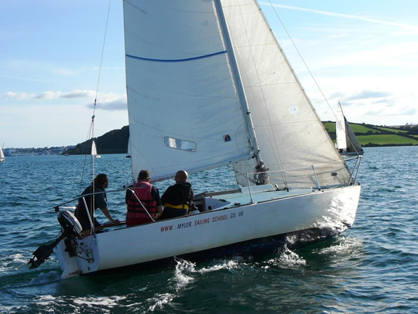
Our sailing boats have some adaptations although there are none that have wheelchair access or for those who cannot sit unaided at present. See ‘Future Plans’ in this statement for news on this. We do have some light support seats and also various shaped cushions to help with comfort and you can ask a member of staff if you require anything like this.
See the list of extra equipment available below.
We mainly use small yachts which can take up to 4 people plus the instructor. Getting onto the boats is a small step up of approximately 3 inches/7.5cms.
We also have intermediate steps that we can put in place to help you step down into the cockpit.
The step down with the help of the intermediate step is approximately 6-8 inches/15-20cms.
You can either sit back and relax and be sailed or you can get involved as much as you want to, this is up to you. A sailing session could take you out towards Black Rock. You can also gain RYA achievement certificates for sailing. More details below on how to start these or ask a member of staff.
There may also be an opportunity to get involved with the more competitive aspect of sailing with some racing. We currently race on a Friday evening with Mylor Yacht Club against all able bodied sailors and this is great fun. If you are interested in trying this then please contact us on the details at the bottom of this web page.
The boat may heel over a little as shown in this photo but this boat will not capsize as it has a very heavy lead keel under the water that prevents this. This is perfectly normal for the boat to lean over a little and it is very safe.
Our classrooms have a 1:12 ramp access (recommended) and the door is the standard 31.5inches/80cms width and can be accessed at an angle with plenty of room to turn into the doorway. Classrooms include projector, screen and hearing loop facility.
Ramps give access to a pontoon by a slipway and there are boats adapted for those with special access requirements as in the pictures above.
Lighting in all huts are fluorescent tubes.
Tables are wheelchair friendly in the classrooms for covering the theoretical aspects of the sailing or powerboating courses.
Booking & Pre-Arrival
You can book into our sessions by either calling 01326 377633 or emailing info@mylorsailingschool.co.uk or online via the ‘BOOK HERE’ section on the website – www.mylorsailingschool.co.uk
There are specific sessions for people with a learning difficulty or physical disability, please check the Sailability section of the website for timings and prices etc. You can click HERE to be taken there direct.
All waterproof clothing and safety equipment is provided and help is available from our well trained staff and instructors.
Booking confirmations available in large print, please just ask if you would like this option.
Easy read leaflets also available.

Visiting us
For full details of our location you can check the ‘contact us’ on the website – www.mylorsailingschool.co.uk which contains grid references, Google maps information and Satellite Navigation information.
Our Post Code TR11 5UF (please read below though as some Sat Navs can take you on the wrong route)
For full details of our location you can click HERE which contains grid references, Google maps information and Satellite Navigation information.
Train -
The nearest train station is Penryn. You will need to take a train to the main station in Truro and then change here for Penryn. You can then take a taxi to Mylor Yacht Harbour which is approximately 10 minutes.

Click HERE for the National Rail Penryn Stations made Easy for their Access information.

Taxis -
Able Cars 01326 373007 or A 2 B 01326 378262. These taxi services have accessible facilities.

Bus -
The nearest bus from either Truro or Falmouth will take you to the top of the hill out of Mylor. It is then a ten minute journey down the hill. (For people with restricted mobility, you will need to take a taxi from the top of the hill by calling one of the numbers above. For further information or advice on this then please do not hesitate to get in touch)

Water Taxi –
Falmouth Water Taxi can take you from either Falmouth or The Roseland. Please check their website for the timetable as it is constantly changing: http://www.falmouthwatertaxi.co.uk/fwt/index.asp
They can also be reached on 07522 446659 for a private hire. Some accessible facilities depending on the boarding location but contact them direct for further information.

By Car & Parking Facilities -
Parking is free and easy with one of our parking passes which will be given to you on arrival. There are no specific Blue Badge spaces on our quay but if you require a large space and also one close to the school then please just call ahead and this will be saved for you immediately in front of the premises. If you cannot find a parking place at peak times then please come to the school and we will direct you to a suitable place to park which will be right outside the main school.
Dropping off is easy and this can be done right outside the main school. There are no kerbs.

Arrival & Access, Public Toilets and Showers
The sailing school is based on a level quay with a smooth surface and great access straight to the sailing school.
The main sailing school consists of large huts and the doors are always open so no need for an intercom and no entry restrictions. Waterproofs and safety equipment is chosen for you by your instructor and ramped access into the classroom for is available if it is raining.
The yacht harbour itself is on a level hard tarmacked surface throughout.
If you require assistance from your vehicle then this is no problem and there are always staff around to assist with this. If you require special assistance then please notify us on booking.
Most of the sailing school and classroom access is level with a slight downhill part towards the slipway and pontoon for boarding the boats. There is no handrail on the pontoon but staff are available to accompany anyone.
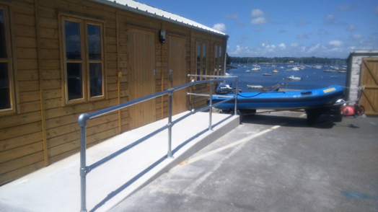
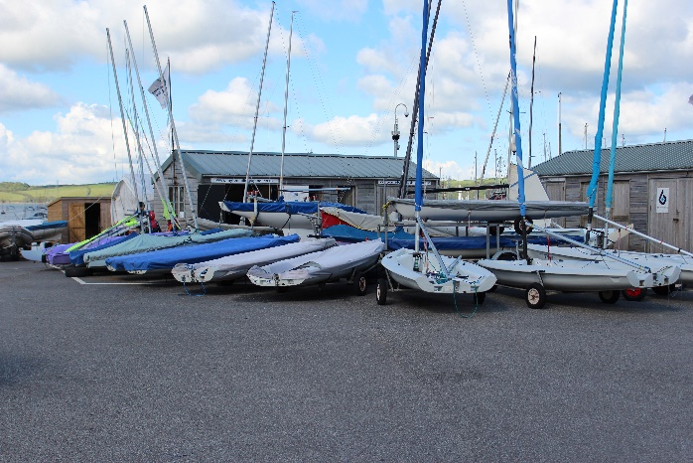
Outside Main School Hut Ramped classroom access 1:12
Seats are available and laid out in front of the sailing school for ease of putting on waterproofs and life jackets.
Payment for your course/session is easy by either paying online or straight to your instructor on arrival. There is no glass or other restricting elements with this part of the process. Parents or Carers have a £5 fee.
There are great facilities for toilets and showers including accessible facilities within the harbour which is well sign-posted. Unfortunately there are no toilet facilities on our quay as this is a English Heritage Site and there is no superior plumbing! The harbour facilities are approximately 330yards/300m from the site. The door is the standard 31.5inches/80cms width and can be accessed straight on and is not at an angle. There is a coded access to the door and this is given on request so please just ask any staff or contact us on 01326 377633 prior to your arrival if required.

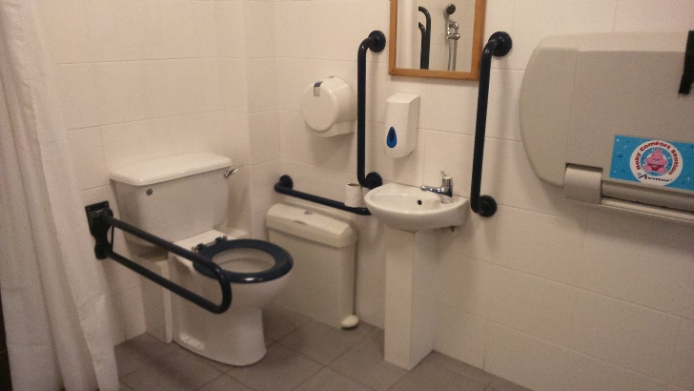
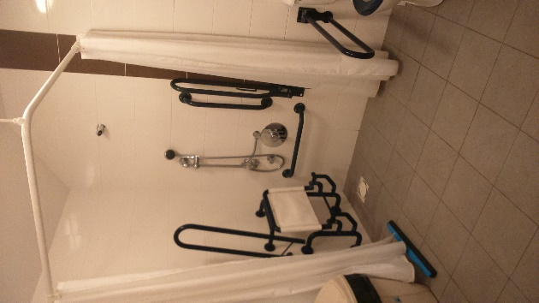
It is also possible to park right outside these facilities.
If you require assistance to get to the shower and toilet facilities then please do not hesitate to ask one of our members of staff who will be glad to help. There is changing facilities for infants

and toddlers but not for anyone weighing more than 5.5stone/35kgs. There is a very large area with a long 5 foot/1.5m bench inside the shower room though that could be used. Sanitary bins available inside the accessible shower and toilet room.
Extra Equipment Available
Lightweight Manual Wheelchair - We have a large lightweight manual wheelchair which is available for use to go out on the water in case clients are unsure about taking expensive electric chairs.
Mobility Walker - There is a walker to assist those with some mobility issues to get from the school and down the ramp onto the boats.
Cushions and Comfort - Some bean-bag cushions available to add more comfort on the boats.
Seat Supports - Light support seats for those that can sit mainly unaided but may just need a small amount of support.
All this equipment is available free of charge so please just ask your instructor.
Assistance Dogs
Assistance Dogs are welcomed at Mylor Sailing School. Life jackets available for dogs. Water bowls are available with an outside tape right in front of our premises.
For dog exercising, there is a small amount of grass within 100m of the school and a beach close by. There is also an area of grass for exercising dogs very close to the premises, a member of staff will direct you to this and for help with exercising your dog, just ask one of the instructors who will be happy to assist.

If you have any questions about how your dog can join you on the boats then please do not hesitate to contact us prior to your arrival.
The cafe and restaurant in the harbour allow all dogs and of course assistance dogs. More information regarding Assistance Dogs and your rights can be found on the Assistance Dogs UK website can be found HERE

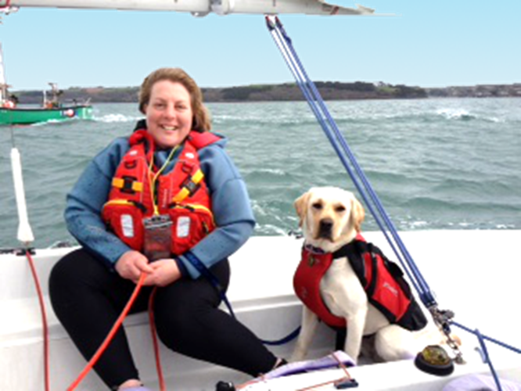
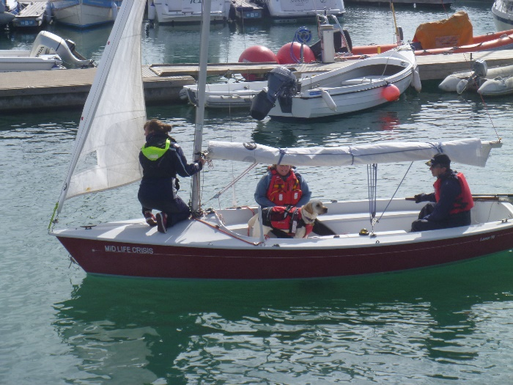

Staff Training
All staff teaching on the Accessible and Sailability sessions have had Disability Awareness training, Dementia Awareness training, Downs Syndrome and Austism in Sports training. All instructors are first aid qualified. All staff teaching on the accessible sessions have a lot of experience working with many types of physical disabilities and health impairments and also learning disabilities. All instructors have been checked through the DBS/CRB scheme. If you have any specific questions then please do not hesitate to ask. Staff training is on-going and we always welcome any suggestions and feedback that you can give us which will help us to make your experience more enjoyable. Just contact us to give us your feedback.
Future Plans
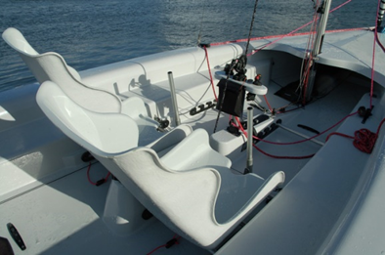
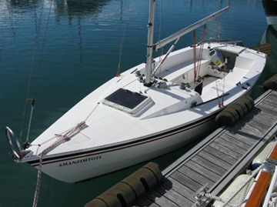
We have just added a new keelboat to the fleet this year 2017. We will be able to hoist people who cannot sit unaided into a support seat for a more comfortable experience onboard one of our boats.

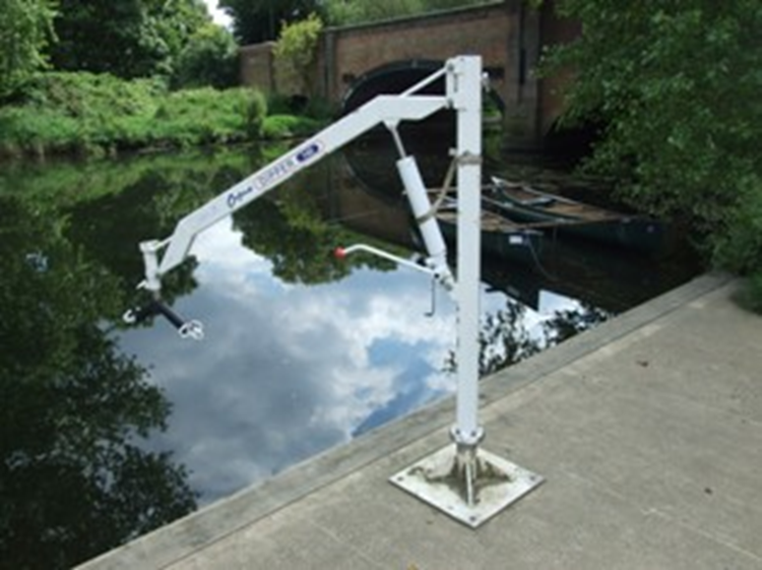
Hawk 20 Keelboat With added Support Seats

Not actual hoist as not in situ as yet, but this is essentially what it will look like
This is called a Hawk 20 which is 20 feet long and has a lifting keel. The keel is a large piece of steel plate that comes out of the bottom of the boat and prevents it from drifting sideways. This will mean that the boat will be able to get alongside our pontoon at any state of tide.
With large open cockpit area. The support seats are not yet added to this boat. This boat is ready for use now and we are hoping that the support seat will be available by the end of March 2018. This boat is very versatile and will offer recreational sailing and also competitive sailing

Facilities Available around Mylor Sailing School
Mobility Scooters and Electric Wheelchairs – can be charged at Mylor Sailing School.
Café – There is a great café approximately 200m from the sailing school with ramped access and an outdoor and indoor seating areas. You can enjoy a great breakfast, stunning lunches or take away, with Tregothnan tea, Puro coffee and cakes from the sunny terrace or the spacious interior, whatever the weather. This is Café Mylor and pre-booking is not necessary but if you would like to contact them for any information you can call them on 01326 377743 or email them on info@cafemylor.com . Go to their website - http://www.cafemylor.com/ for menu choices. Accessible toilet inside. Family and dog friendly.
Bar & Restaurant – Castaways is a lovely bar and restaurant in the harbour and offers a perfect blend of Italian-style cuisine, quality seafood, locally sourced produce, draught beers, great wine and stunning views. It is adviseable to book in peak times and you can either contact them on 01326 377710 or email info@castawayswinebar.co.uk. You can also book online and see their menu here http://www.castawaysmylor.com/ . There is a lot of outdoor seating with picnic style benches.
Wheelchair users will need to use the far side entrance as there is a step and heavy door at the front entrance. Assistance is always available from their helpful staff. Accessible toilet inside. Family and dog friendly.
Nearest Small Grocery Shop - Mylor Bridge Stores, approximately 1 mile from Mylor Yacht Harbour. This sells lots of good local products and has a small bakery section. Newspapers and a post office are a little further up the hill from the Stores. Not wheelchair accessible although the staff are very friendly and will help you with anything you need.
Nearest Supermarket - Sainsbury’s, approximately 2 miles from Mylor Yacht Harbour. Follow signs to Falmouth and it is off to the right on the roundabout near MacDonalds. Wheelchair accessible. Accessible toilets.
Nearest Petrol Station - Texaco Garage, Commercial Road, Penryn, approximately 2 miles from Mylor Yacht Harbour. Not wheelchair accessible but there is one ‘pay at the pump’ facility. No Accessible toilets.
Nearest Cash Point Machine - Sainsbury’s, details as above.

Accessible Accommodation
There are some recommendations on our main website under the ‘links’ page for accommodation, including accessible information, but here are some specific places -
Self Catering -
Mylor Apartments - There are some self catering apartments in Mylor Yacht Harbour on ground level and the Paralympic team stayed here for their sail training in 2011 for most of the summer. 01326 372121, and website link https://www.mylor.com/holidays/home/ or email enquiries@mylor.com
Penryn Self Catering Apartment - (approx 3 miles from Mylor) This is a beautiful self-catering holiday home via Falmouth Holiday Cottages Letting Agents and this is designed for wheelchair users. It is all on one level, has a wet-room, low level appliances and its ground floor. The apartment is called ‘Quayside’ and it is purpose built for wheelchair users. This is the direct link to it - https://falmouthholidayhomes.co.uk/Properties/Quayside You can also either call them or there is a facility on their website for a ‘live chat’ for the hard of hearing.
Gwel an Mor - is a holiday village near Portreath. (This is approximately a 35 minute drive from Mylor). The direct link to their accessible accommodation is http://www.gwelanmor.com/stay/accessible-acommodation- They also have an Access Statement - http://www.gwelanmor.com/legal/access-statement
Premier Inn Hotel– Carnon Downs (approx. 8 miles from Mylor), with a few rooms that are wheelchair accessible. It is situated on the A39 between Falmouth and Truro. TR3 6JZ for their postcode. Although they have good facilities for wheelchair users their phone number is a premium rate one with a 13p per minute charge 0871 527 9222 so it is best to book direct online. This is their direct Carnon Downs weblink. http://www.premierinn.com/gb/en/hotels/england/cornwall/truro/truro.html?cid=GLBC_TRUOLD
Camping - There are a couple of options that we know of –
Retanna Holiday Park - near Falmouth (approx. 10 minute drive to Mylor) and they have Some of their caravans have low thresholds and access has been possible for certain mobility impaired guests. They would be pleased to discuss limitations when making a reservation. For hearing impaired guests teletext T.V. with subtitle service (888) is available in all caravans. They do not have a fully converted wheelchair access holiday caravan but are working towards this facility.
Read their access statement here - http://www.retanna.co.uk/access_statement.php
Phone 01326 340643 or their main website is http://www.retanna.co.uk/
Menehay Farm Touring Park – Budock Water near Falmouth (approx. 15 minute drive to Mylor). They have ‘full disabled facilities’ as per their website. They do not have an accessibility statement.
You can contact them on 01326 372550 or their website is http://menehayfarm.co.uk/
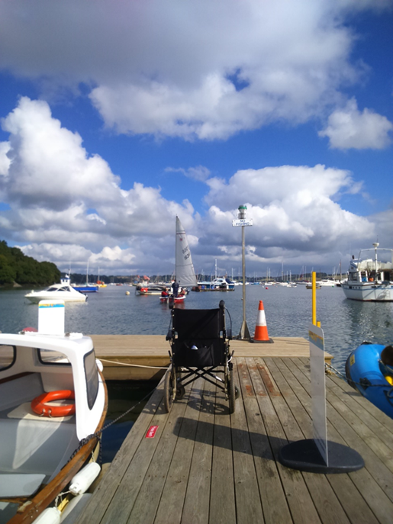
Gone sailing….
Should you have any further needs or queries whatsoever - please ask
Everyone at Mylor Sailing School is here to help
Full Contact Details
Address - Mylor Sailing School, Mylor Yacht Harbour, Falmouth, TR11 5UF
Telephone – 01326 377633 or 07971 520257
Email – info@mylorsailingschol.co.uk Website – www.mylorsailingschool.co.uk
Grid Reference - 50.1772946 and 5.05432615
Google Maps Satellite ref –
https://www.google.co.uk/maps/@50.1775288,-5.0565513,741m/data=!3m1!1e3

Hours of Operation – 7 days per week, all year round - 9am – 5.30pm (later in July and August)

Customer Feedback or Suggestions
If you have any comments regarding this Accessibility Guide or our sessions, or have noticed any inaccuracies then please let us know by clicking HERE for our contact details or speak to a member of staff who will be happy to help you.
Road into Mylor Yacht Harbour
Café
Accessible toilets & Showers

Left turning from road onto Admiralty Quay
Mylor Sailing School

